WEEK 2: Product and Category Management System
-S.KAVIYA (E25AI119)
Scenario:
The Art Work Shop wants to maintain information about products and their categories. Each product belongs to a specific category, and the system should manage product details such as name, price, and stock availability.
1. Product and Category Tables:
Category table:
Product table:
Product and Category tables are created
2. Define Relationships and Constraints
Relationships:
One Category can have many Products.
The relationship between Category and Product is One to Many (1 → *).
Primary Key:
In Category Table, Category_ID uniquely identifies each category.
In Product Table, Product_ID uniquely identifies each product.
Foreign Key:
Category_ID acts as Foreign Key in the Product Table.
Other Constraints:
NOT NULL: Product name and category name cannot be empty.
Example: The Product_Name and Category_Name fields should not be left empty because they are required to identify the records.
CHECK: Product price must always be a positive number.
Example: The product price must be greater than zero, so an invalid negative price cannot be entered.
UNIQUE: No two categories can have the same category name.
Example: Every category should have a different Category_Name. Two categories cannot be created with the same name.
Defining relationship and create constraints for product and category:
Primary key:
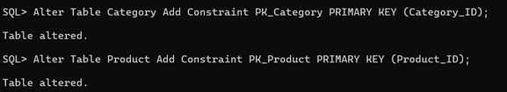
Creating relationship using Foreign key:
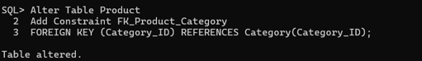
Adding constraints
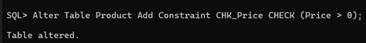
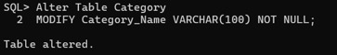
not null:
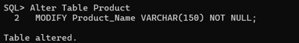
Check:
Unique:
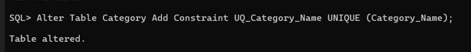
3.Inserting values :
Category Table:
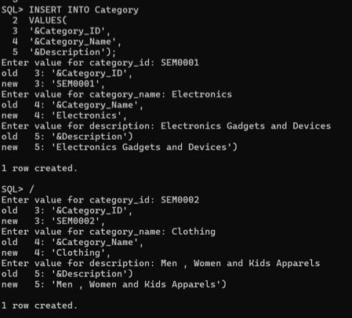

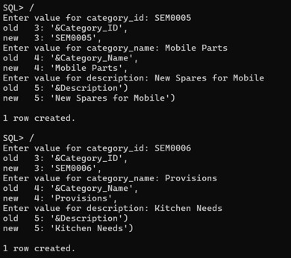
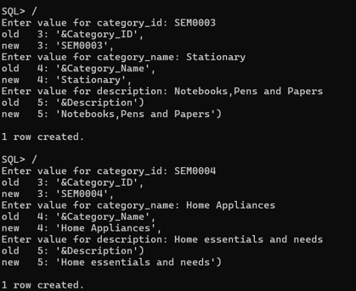

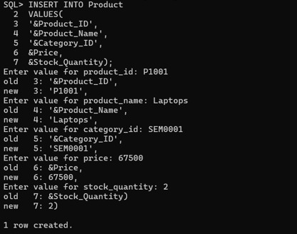
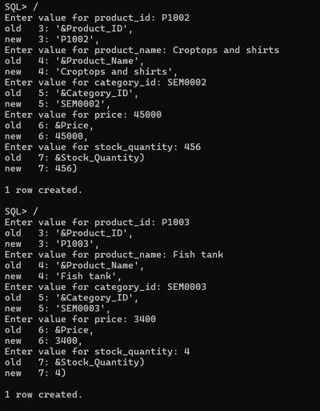
Product table:
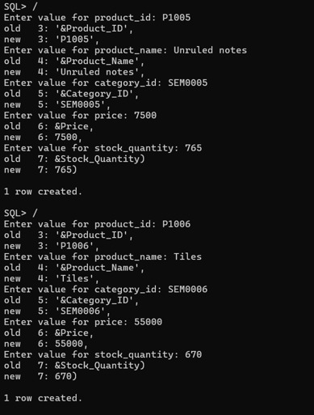
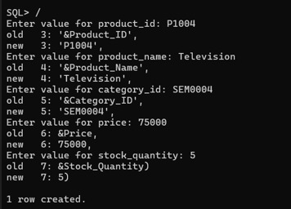

After insertion category table:
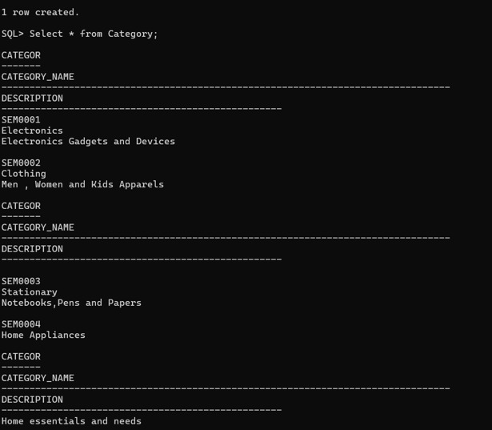
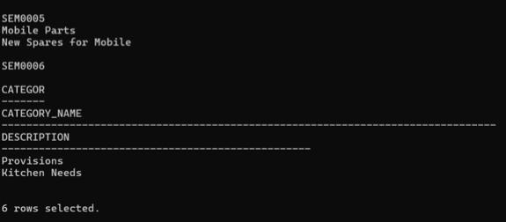

Aftet insertion product table:
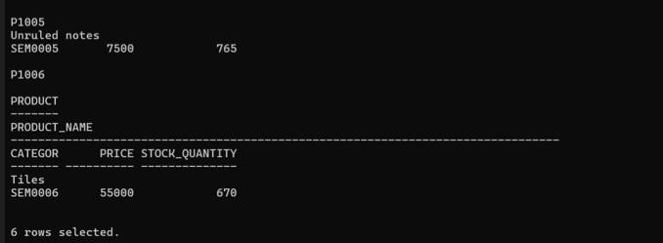
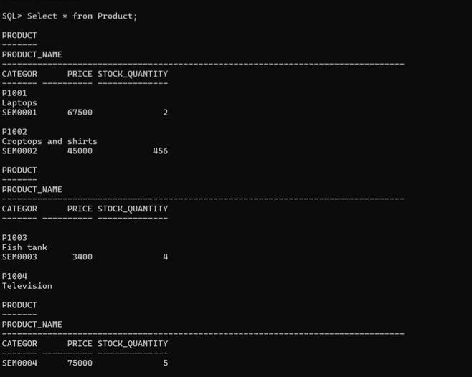

CRUD OPERATIONS:
Insertion record:
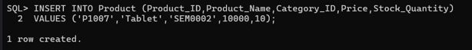
Update price:
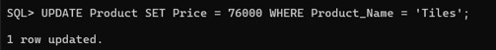
Delete a product:

4. Category-Wise Product Reports:
SQL query:
SELECT c.CATEGORY_ID,
c.CATEGORY_NAME,
p.PRODUCT_ID,
p.PRODUCT_NAME,
p.PRICE,
p.STOCK_QUANTITY
FROM product p
JOIN Category c
ON p.CATEGORY_ID = c.CATEGORY_ID;
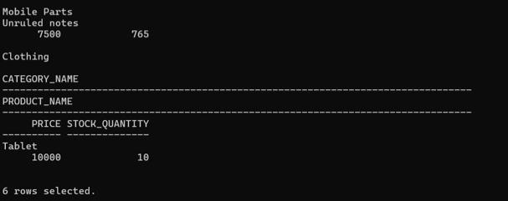
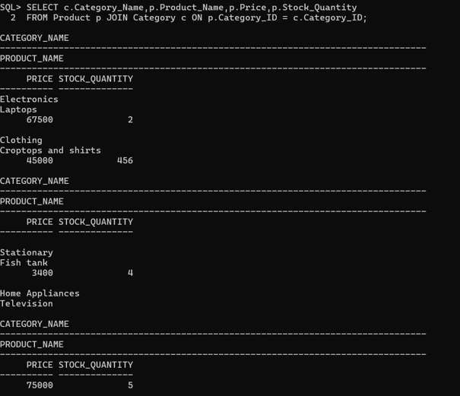

Counting Number of products in each Category:
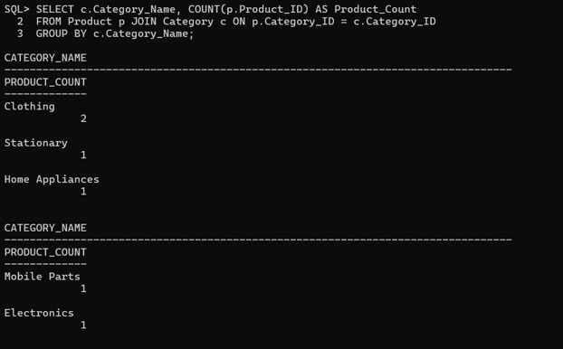
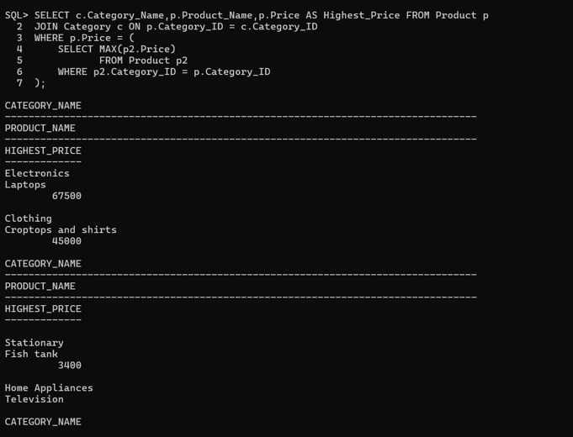
Finding highest priced product in each category:
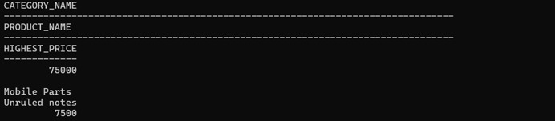
Display categories having more than 5 products
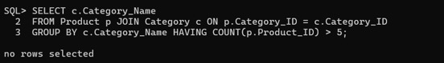
No rows selected because all categories having less than 5 products.

Find average product price category-wise
